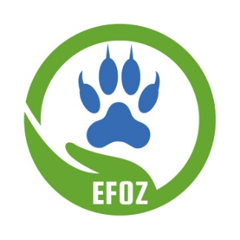
Code of Conduct

The Emporia Friends of the Zoo (EFOZ) is dedicated to providing a pleasant event experience for attendees and staff at EFOZ events benefiting the David Traylor Zoo of Emporia. All participants are expected to adhere to this Code of Conduct at all EFOZ events. Participants at events held at zoo facilities must also observe and follow the David Traylor Zoo Rules

Alcohol and Drug Use
Emporia Friends of the Zoo events serve both alcoholic and non-alcoholic beverages. Participants are expected to drink responsibly. Alcohol may not be possessed or consumed by minors and may not be removed from event boundaries. Event staff have the right to deny service to participants for any reason and may require a participant to leave the event. The use of tobacco products and/or illegal drugs is prohibited.

Behavior
Treat people, facilities, and animals with respect. Disruptive, dangerous, or illegal behavior will not be tolerated. Harassment of any kind, including sexual harassment is prohibited. Event staff will take appropriate and immediate action in response to complaints or knowledge of violations of this policy.

Agreement
By participating in an EFOZ Event, you agree to abide by the David Traylor Zoo Rules (when applicable) and EFOZ Code of Conduct as outlined above. You further acknowledge and accept that event attendees may be filmed, videotaped, or photographed. Your admission to the EFOZ event serves as permission for use of your image by the City of Emporia, and/or EFOZ for promotional purposes. All attendees acknowledge that they are voluntarily choosing to participate in the EFOZ event and agree to assume any inherent risks associated with such participation.

